Customizing Adobe Acrobat for Digital Grading of PDFs

This document guides you through:
1) Displaying the Quick Tools toolbar in Adobe Acrobat DC
2) Customizing the Quick Tools toolbar with items you will commonly use
3) Adding custom stamps like  and 
4) Turning on “hot-keys” to access your grading tools with a single key-stroke

Note: You can sign up for Adobe’s Creative Cloud using your KPU email address and then download Adobe Acrobat DC, which allows you to annotate PDFs and thus digitally-grade student work. This document does not detail how to do that, however.

To Display the Quick Tools Toolbar

Click View > Show/Hide > Toolbar Items > Show Quick Tools

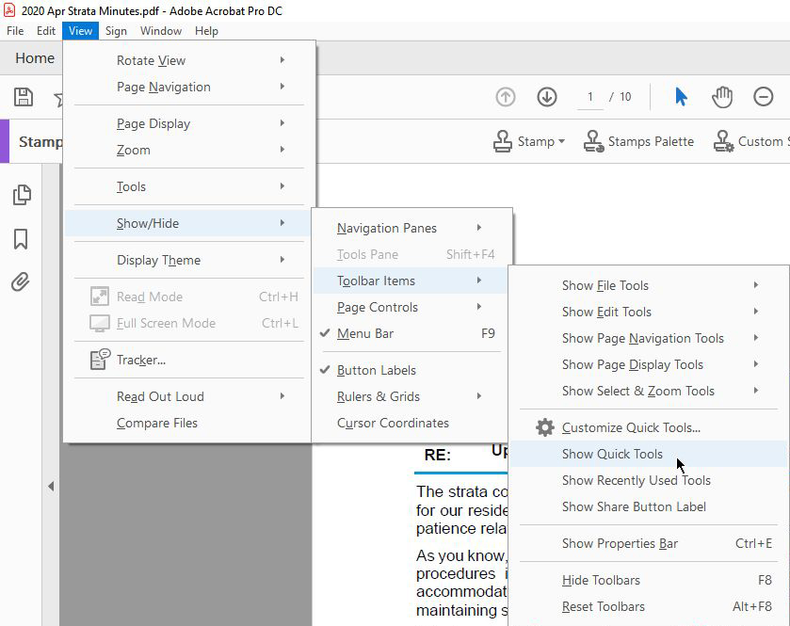

To Customize the Quick Tools Toolbar

You will now want to add tools you commonly use to the Quick Tools toolbar.

These are the ones I find most useful for grading:

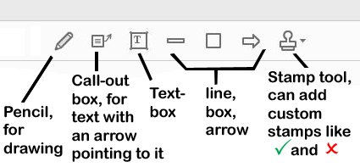

Here’s how to add an item to your Quick Tools toolbar (I’ll use the Stamp tool as an example).

1) Click View > Show/Hide > Toolbar Items > Customize Quick Tools…

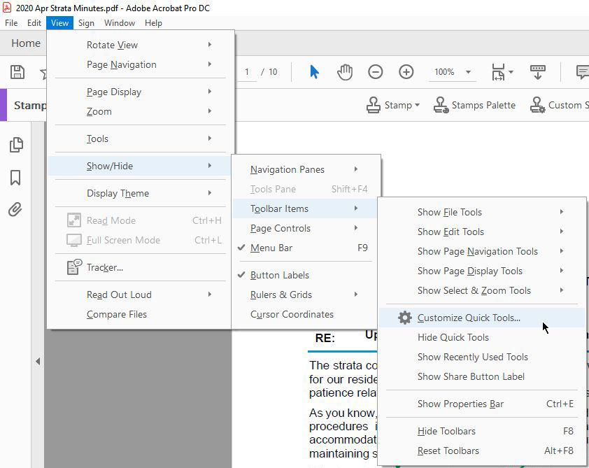
2) On the dialogue box that appears, select Comment (this is for the Stamps tool; you can explore other menus also)

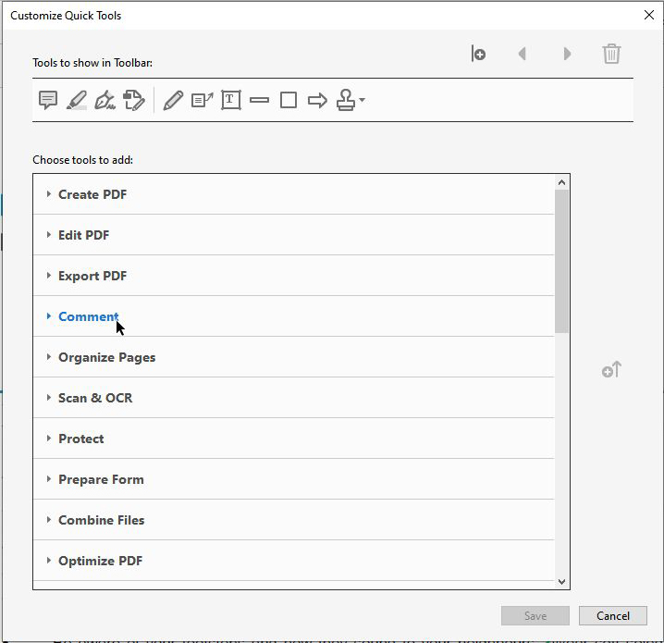

3) Next, select your tool (the Stamps tool, in this example) and “promote” it onto the toolbar with the “Add to Toolbar” icon on the right-hand edge of the dialogue box

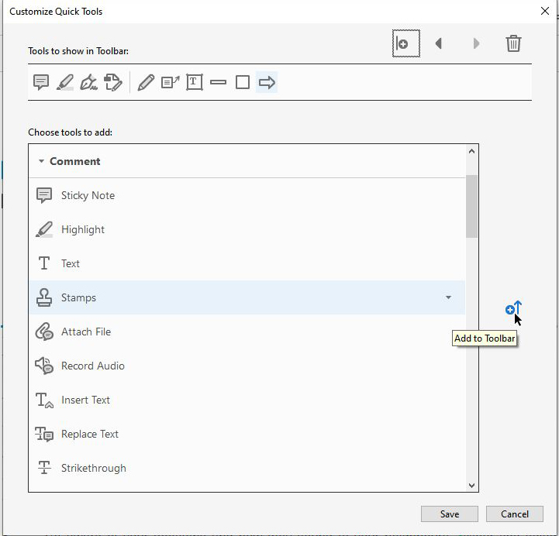

4) Having now added the tool to the toolbar, click Save

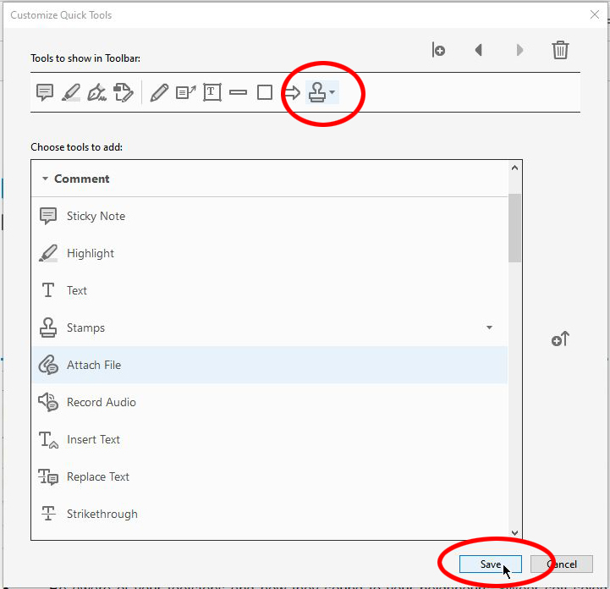

5) Your newly-added tool should now appear on the Quick Tools toolbar alongside whatever other tools you have there.

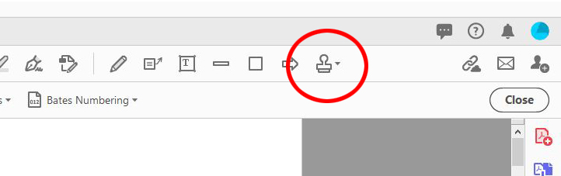

Adding Custom Stamps

One of the most useful ways to use the Stamps tool is by creating custom stamps like like  and  and adding them to your “Favorites” for easy access.

The following images can be copied out of this document, to be used as custom stamp images, by clicking on the image below, then right-clicking on it, then selecting “Save as Picture”.

Alternately, these images correspond to capital O () and capital P () in the Wingdings 2 font. It is best to create them on a transparent background and save them in the PNG format in order to preserve that transparency.

Once you have the images you intend to add to Adobe Acrobat as custom stamps, do the following:

1) Do a search for the word “stamp” in Adobe Acrobat DC. Locate “Custom Stamps”, click on it, then select “Create…”

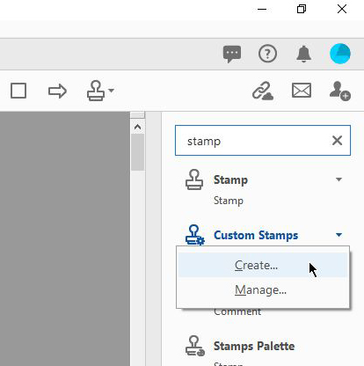

2) In the dialogue box that appears, click “Browse” and navigate to the image file you want to add as your custom stamp.

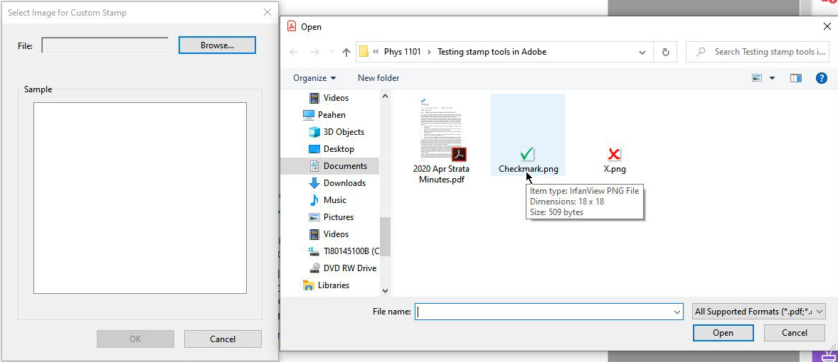

3) Once the image has loaded, click “OK”

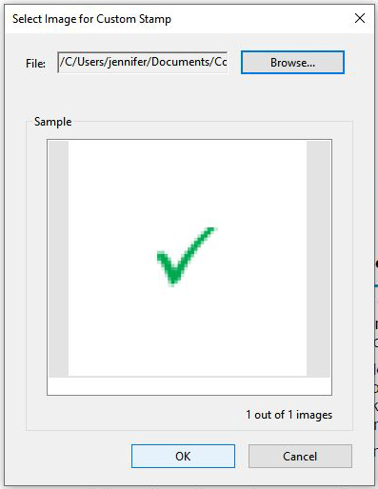

4) Add a category name (e.g. “Grading”) for your custom stamp, and a name for that stamp (e.g. “Checkmark” or “X mark”

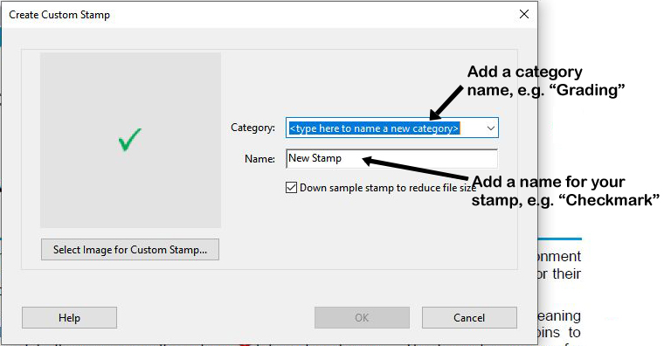

5) On your document, you can now click the Stamps icon, then select the category for the stamp, then find the custom stamp itself.

You’re not done, however! To make it even easier to find, you’ll next add it to your “Favorites”.

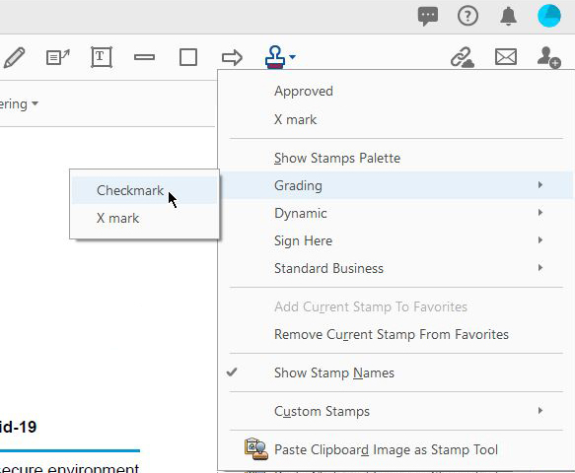
6) Having selected your custom stamp (but not added it to the document yet), you can now click the Stamps icon again, then select “Add Current Stamp to Favorites”
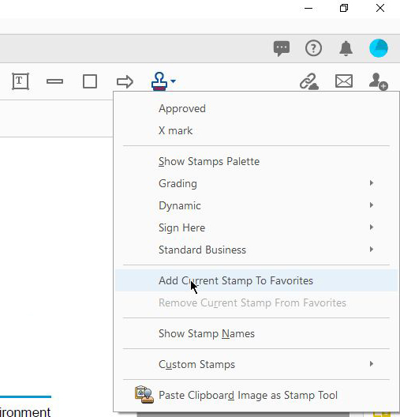

7) When you click the Stamps tool now, your custom stamp should appear at the top

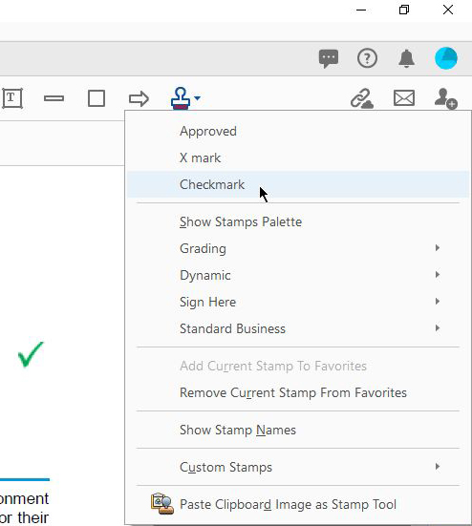
Turning on “Single-Key Accelerators” (Hot-Keys) to Quickly Access Often-Used Tools

Turning on “single-key accelerators” allows you to access tools you use often with a single key-stroke. This is useful to, for example, add a series of checkmarks with only a single key-stroke and single mouse-click each time, rather than navigating through menus to add a checkmark stamp.

1) First, click Edit > Preferences
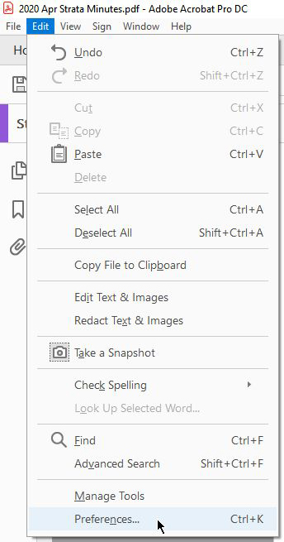

2) Next, check the box for “Use single-key accelerators to access tools”, then scroll down and click “OK” to save the setting
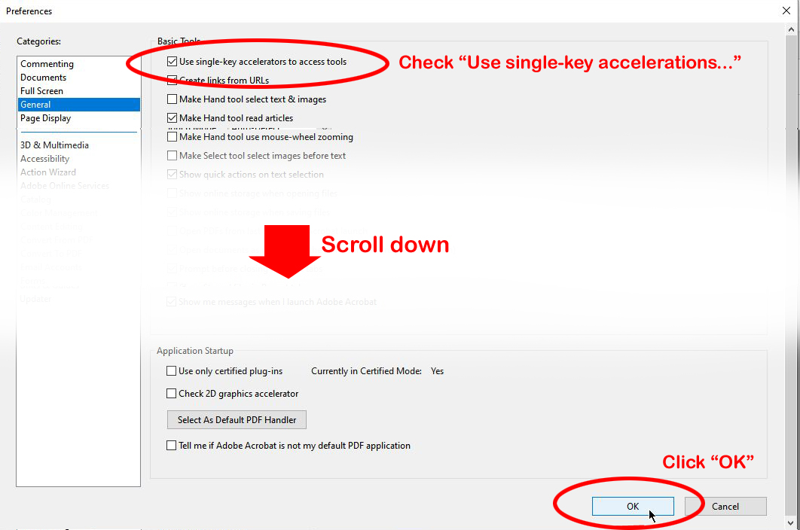

3) Clicking the correct single-key will now allow you to access various tools.
